**Configuration Values Setup for CRM**

Below image shows the set of configurations which we need to get from AAD(Azure Active Directory) and CRM instance.

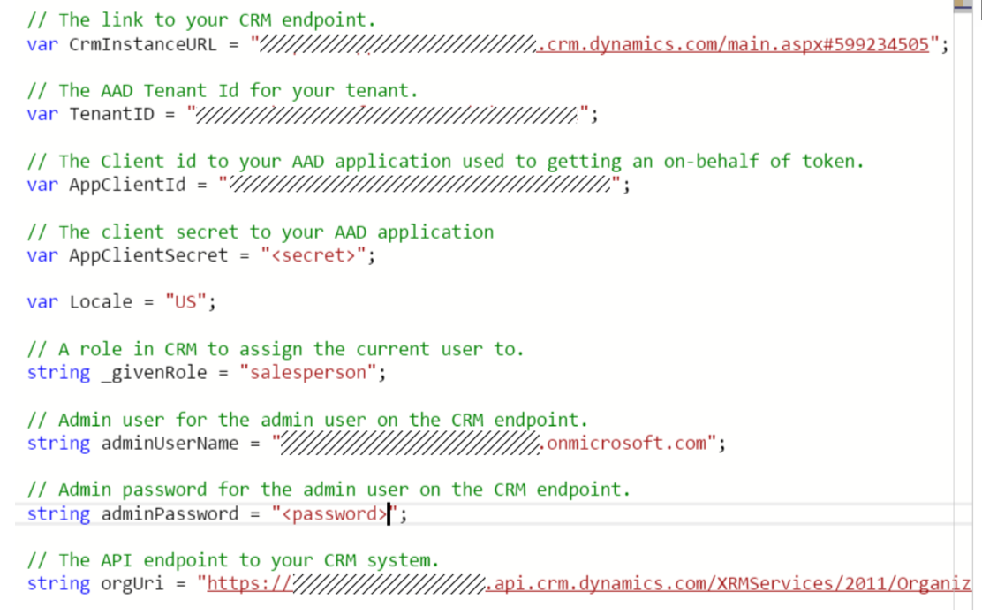

* **TenantID** :

It’s the AAD tenant id where the application is registered.

Azure Active Directory -> Properties -> Directory ID

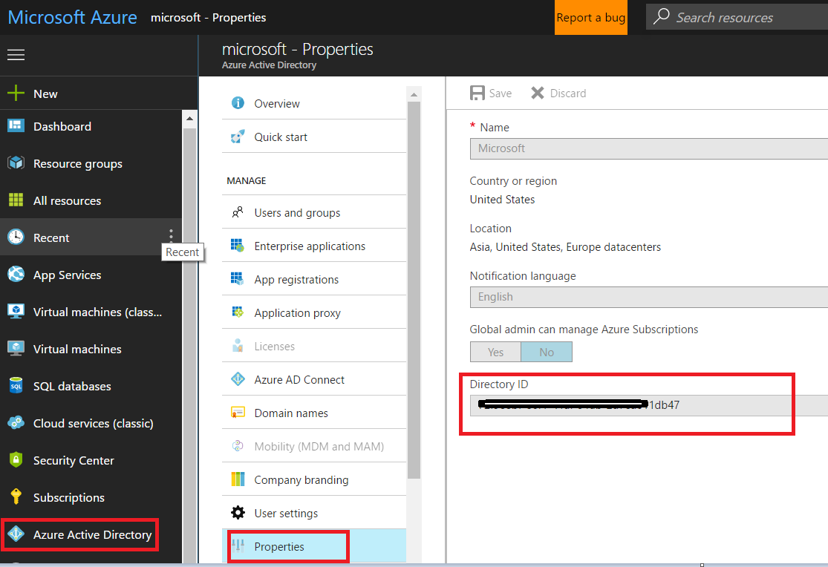

* **AppClientID:**

Your registered application ID

Azure Active Directory -> App Registrations -> Registered App -> Settings -> Application ID

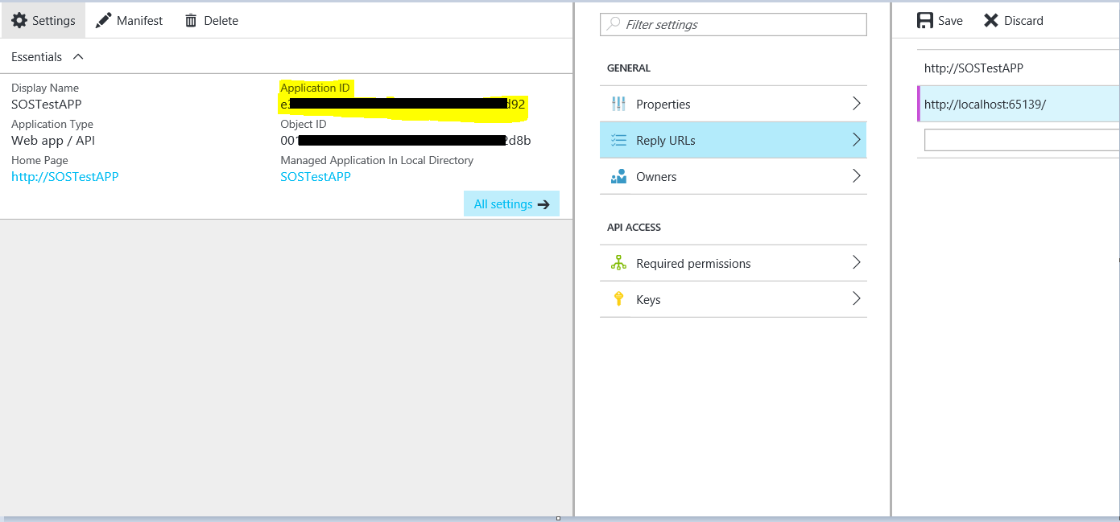

* **AppClientSecret:**

Your registered application Secret

Azure Active Directory -> App Registrations -> Registered App -> Settings -> Keys -> your newly created KEY

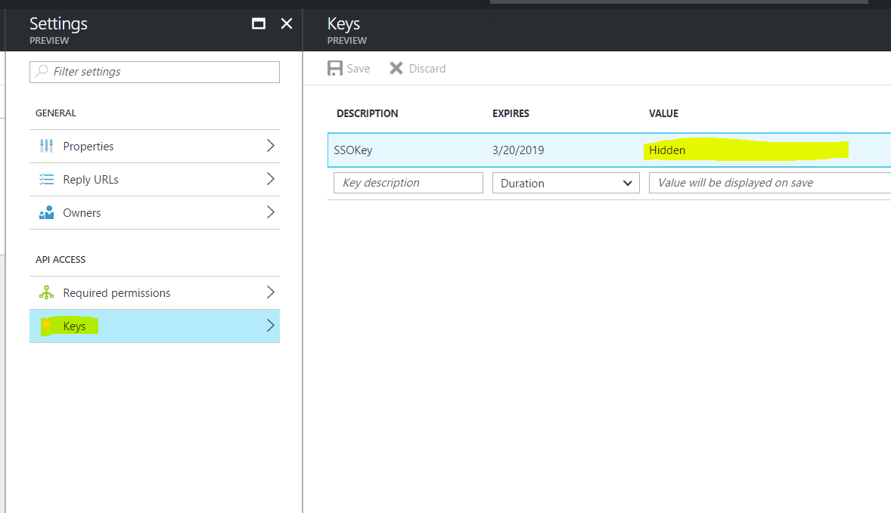

* **CrmInstanceURL:**

Your CRM instance URL. It looks like

<https://yourCRMinstancename.crm.dynamics.com/>

* **_givenRole:**

Login to your CRM instance with Admin credentials

Settings -> Security -> Security Roles -> Create/Edit security role -> Role name

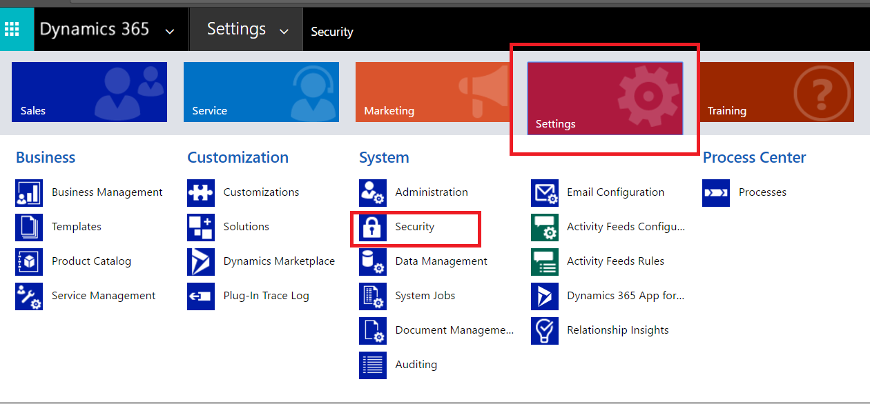

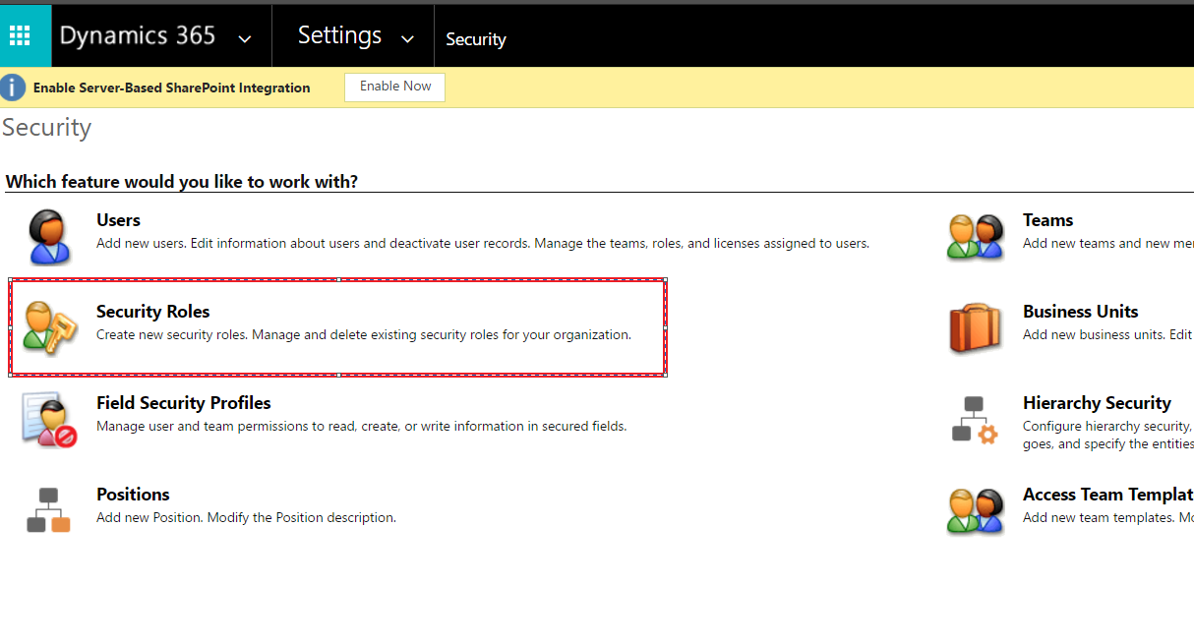

Double Click on new Role/Existing role, it will give a pop up window with role details.

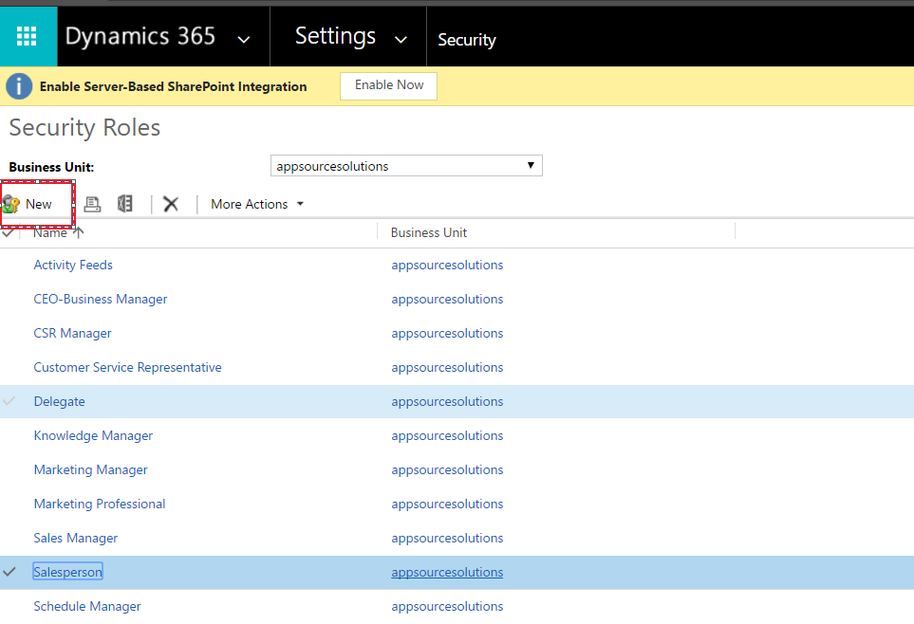

Role Name as shown below is the your given role name

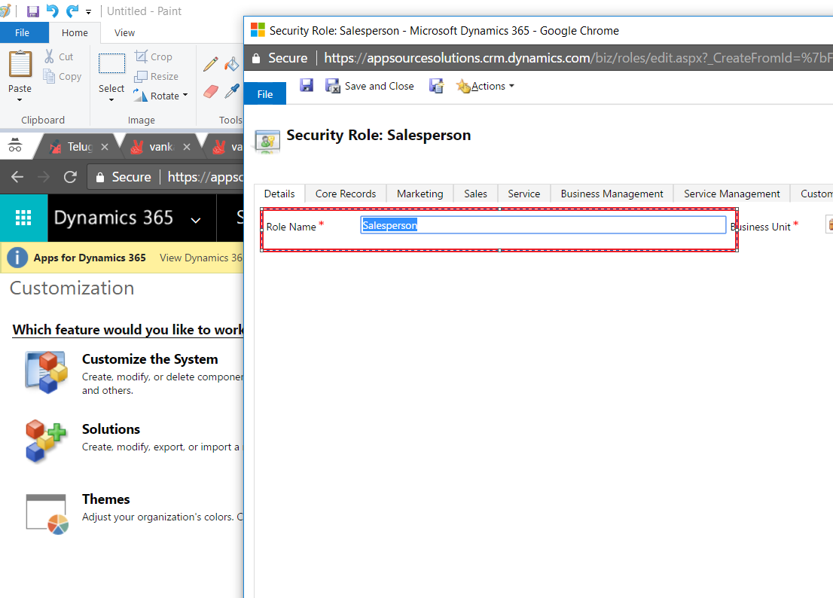

* **adminUserName:**

Your CRM instance Admin user name.

* **adminPassword:**

Your CRM instance Admin user password.

* **orgUri:**

Login to your CRM instance with Admin credentials

Settings -> Customizations -> Developer Resources -> Organization service Endpoint Address

